Sri Lanka Institute of Information

Technology



Lab Submission

<Lab sheet 10>

**IT24102953**

**Yasara R.P.M**

**Probability and Statistics| IT2120**

B.Sc. (Hons) in Information Technology

**Exercise**

**Q1.**

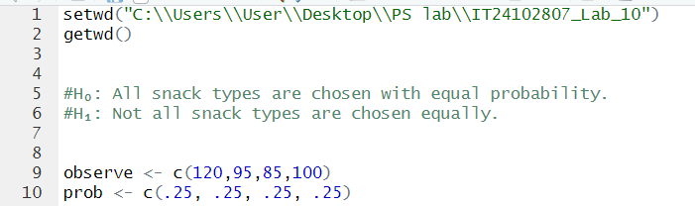

**Q3.**

* we fail to reject the null hypothesis (H₀).

There is **no significant difference** in the number of purchases among the four snack types

This means the data supports the vending machine owner’s claim that customers choose all four snack types with roughly equal probability